Esthetic Crown Lengthening

← Diagnostic
Wax-Up

Stent with Diagnostic Cast
↓
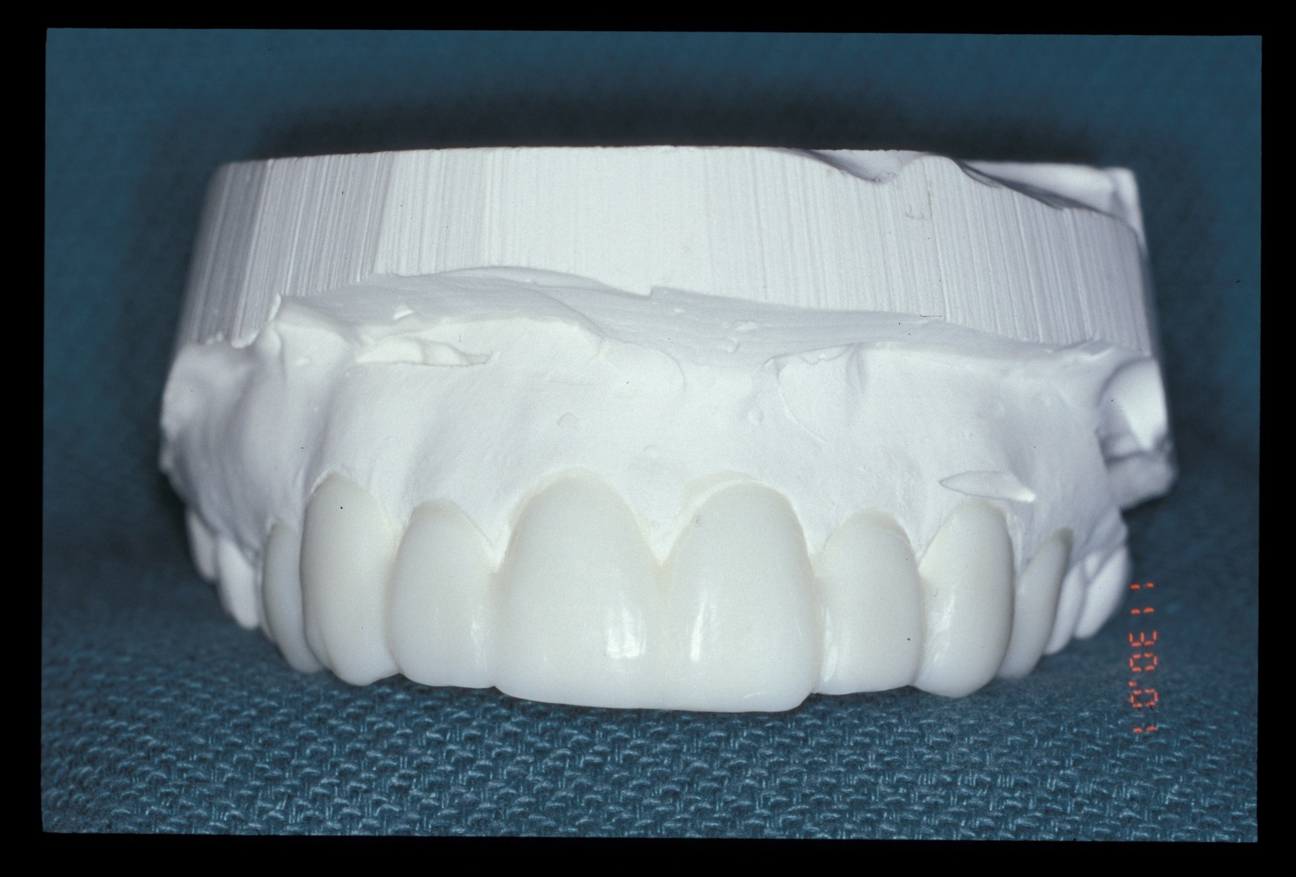

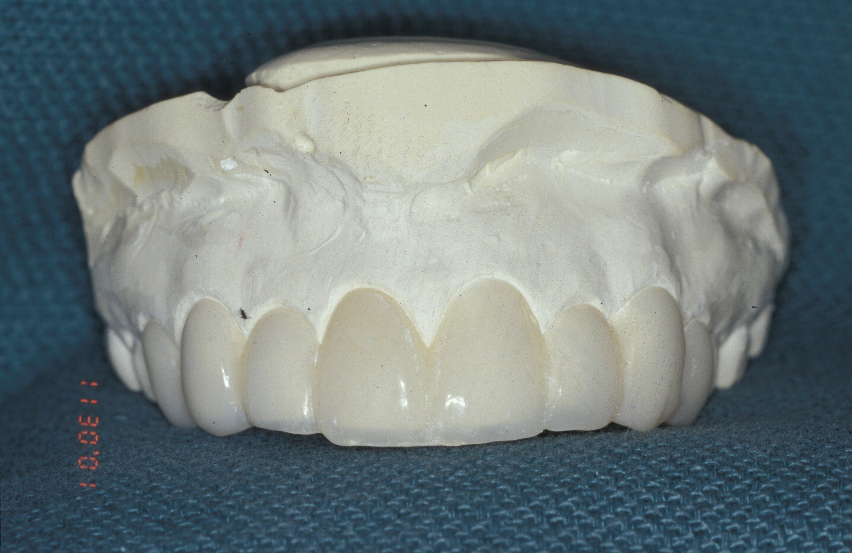
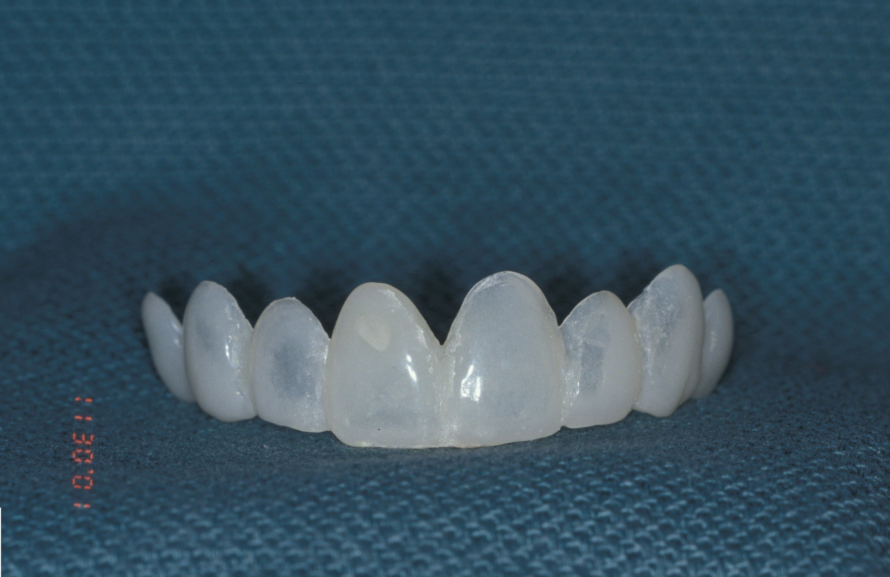

Surgical Guide

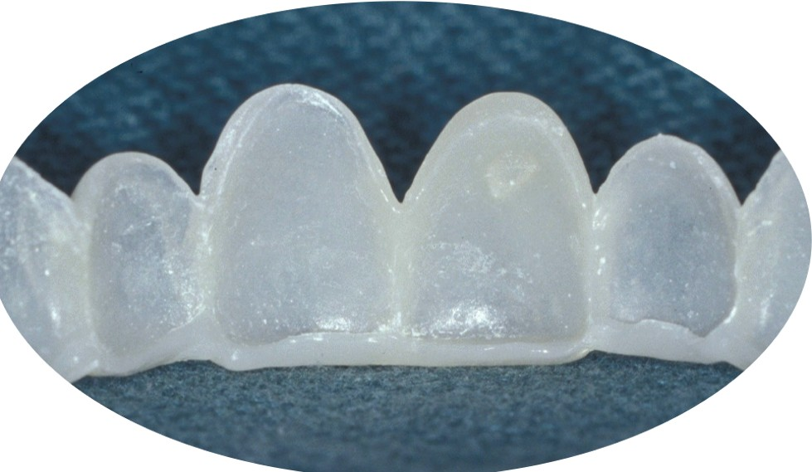

Lingual/Palatal View

1). Fabricate a diagnostic cast for treatment planning purposes – (this can be a multidisciplinary approach with periodontist prior to stent fabrication).

2). The diagnostic cast can then be forwarded to the lab for fabrication of the surgical guide. The surgical guide should extend past the teeth involved and engage the incisal edge to help stabilize the guide during surgery.

3). The surgical guide can also be produced as a vacuum form, however I recommend a thicker material and trimming the stent with very precise cervical margins to allow the surgeon to determine the proper biologic width and enhance the esthetic outcome.
4). Try the stent in the patient’s mouth prior to the surgery to determine fit and adjust if necessary

